# Chapter 1: Introduction

### System background

My topic for the project of Computer Programming (CP) is “Futsal Management System”. This system can be used by the local futsal organizations for their daily purposes. It will be a website specially designed to manage the regular activities of a futsal organization. It will help the futsal owners to conduct daily activities without any worries and smoothly. In this website the owners can book the owners can conduct various activities like daily futsal booking, updating events etc. the customers will be able to book futsal for using.

## Justification of Project.

### Background

This system will be built for the users to easily manage and organize a Futsal. It will be a web-based website accessible to the users around the world. It can be used for the satisfaction of the customers. The customers can easily access the website and use the available contents. They can also book the shift they want to use the futsal for.

### Problem Statement

A number of new futsal organizations are being built. This will also increase the demand of the users. The number of users will also increase. They will start demanding about the quality rather than quantity. We should be able to fulfill the demands of the users. To maintain the quality of the website we need advanced features. To add such advanced features some investment is also required so the project budget will also increase according to the demand of the users. The website also needs to be available 24 hours to the maintenance cost etc. will also increase.

## Aim

The major aim of developing this project are:

* Help in futsal management
* Online booking
* Customer satisfaction
* Helping daily futsal activities
* Provide online futsal service.

## Objectives

The objective of making this project are:

* To organize futsal easily
* To carry out daily management of a futsal
* To give users easy access
* To ease the burden of the futsal owners by limiting work

# Chapter 2: Analysis

## 2.1 Introduction to Analysis

Analysis may be defined as the process of collection an gathering of data and information for the betterment of the system. It can be regarded as the first step while developing a software or any type of program. We have to do the analysis in order to collect the required information and make our system better. Analysis is required to get the required functions in our system and run it without any further difficulties.

**Analysis may be defined as the** detailed examination of anything complex in order to understand its nature or to determine its essential features.

Requirement analysis is also conducted in order to gather the requirements that the system will have and the features the users require. We can do requirement analysis through group discussions, interviews, focused groups etc.

For my project analysis plays a vital role for the betterment of my website that I am going to develop.

Some of the types of analysis are:

### P.E.S.T. Analysis:

 P.E.S.T. is an acronym for the Political, Economic, Social, and Technological factors of the external macro-environment. Such external factors usually are beyond the firm's control and sometimes present themselves as threats. P.E.S.T. analysis helps us to deal with various factors involving the political, economic, social and technical aspects.

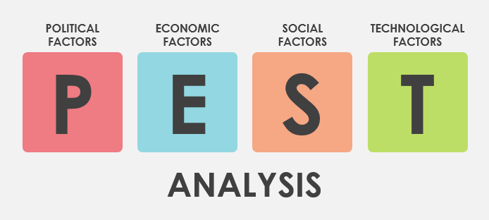

### SWOT analysis:

It is also a type of analysis it helps a company to find its various features. By using this analysis, we can find the strength the company possesses, company’s weakness, future opportunities, and various threats that may occur while operating a company.

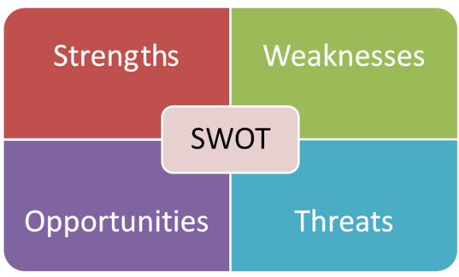

## 2.2 Feasibility Study

Feasibility study covers all the factors while developing a system/software. It helps to develop the software without any trouble. Moreover, feasibility study includes the different study types as economic feasibility, technical feasibility, social feasibility etc.

As per my perspective I will be also analyzing the problems that may arise I the future and the various ways to tackle such problems. This will help my system to last longer and provide quality service.

Some of the types of feasibility study to help my project are:

1. Economic Feasibility:

In this feasibility study the matters that involve money are done. This helps us to analyze that how much budget is required to make our project. It helps us to spend the allocated budget for the project.

As for my project as my project is for academic purpose the budget is not used in any manner. This project is being prepared for academic purpose only.

1. Legal Feasibility:

In this study we check if our project meets the legal requirements of the nation or not. It checks if any kinds of law were breached while developing the project.

My project will be legally feasible because there will not be used any kinds of illegal methods to develop the project. The project will be made under the legal circumstances.

1. Technical Feasibility:

In this study we find out if the project we are about to develop is technically and physically possible or not.

To develop the project i already have all the technical and physical equipment’s so there will not be any kinds of trouble regarding the technical requirements as well as physical requirements.

1. Operational Feasibility:

In this study we find out whether our system operates properly or not or rather that that it checks if our system is able to interact with the users or not.

My project is going to be a simple website so there will be no any problem regarding the operational issues

1. Schedule Feasibility:

This study helps us to identify if our system will be completed in the given time. If our project is completed on time the it will achieve the schedule feasibility.

I have been given enough time for the completion of my project so there will not be any problems regarding the schedule feasibility.

## 2.3 Requirement Analysis

In this method we gather all the necessary requirements and separate the into either Functional or Non-Functional. The analysis is done according to the requirements.

#### Functional Requirement

Functional requirements are directly involved system. They play a major role in development of the system. These requirements are a must have for the system.

Functional requirements included in my project are:

|  |  |  |  |  |  |
| --- | --- | --- | --- | --- | --- |
| Functional ID | Functions in my project | Data | Rational | Dependency | Remarks |
| F01 | Registration | User information | Different names of the users | F01 | Add new members |
| F02 | Login | Email and Password | Give access to the users | F01 | Help to access website |
| F03 | User Update | Information Update | User Information can be changed | F02 | New information is set replacing previous one |
| F04 | Admin Login | Admin details  (Email and Password) | Admin | F04 | Opens admin dashboard |
| F05 | Post Information | Futsal Activities | For the users | F04 | Tournaments,  news |
| F06 | Information  Update | Update futsal details/plans | Update | F04 | Tournament updates |
| F07 | Admin Update (Profile) | Update the admin details | Admin | F04 | Details of the admin will be Updated |
| F08 | Booking | To book | Readers to the admin | F02 | Users can book |
| F09 | Cancel Booking | To cancel booking | Cancellation | F02 | Users can cancel booking |

Table: Functional Requirements

#### Non-Functional Requirements:

These attributes are indirectly related to the project/system. Even though they are indirectly related they play major roles in our system.

Table of non-functional requirements of my project are:

|  |  |  |  |  |  |
| --- | --- | --- | --- | --- | --- |
| Non-Functional Id | Functions | Data | Rational | Dependency | Remarks |
| N01 | Responsive | - | Supports different screen sizes/resolutions | - | Run on various screen sizes. |
| N02 | Reliable | - | Trustworthy | - | Users can rely on website |
| N03 | Robust | - | Multiplatform | - | Should run on different platforms |
| N04 | Usability | - | User friendly | - | Easy to use |
| N05 | Multi-Browser support | - | Tested in different browsers | - | Operates in different browser |
| N06 | Scalability | - | To be able to handle workloads | - | Easy data flow |

Table: Non-Functional Requirements

### MOSCOW Prioritization:

MOSCOW prioritization is a popular [prioritization technique](https://www.productplan.com/strategies-prioritize-product-features/) for managing requirements. It is commonly used to help key stakeholders understand the significance of initiatives in a specific release.

#### MOSCOW prioritization of functional requirements:

|  |  |  |
| --- | --- | --- |
| ID | Functionalities | Priority |
| F01 | Registration | Must have |
| F02 | Login | Must have |
| F03 | User Update | Must have |
| F04 | Admin Login | Should have |
| F05 | Post information | Should have |
| F06 | Information Update | Would have |
| F07 | Admin Update | Would have |
| F08 | Booking | Must have |
| F09 | Cancel Booking | Must have |

Table: MOSCOW Prioritization for the Functional Requirements

``

#### MOSCOW Prioritization for the Non-Functional Requirements:

|  |  |  |
| --- | --- | --- |
| ID | Functionalities | Priority |
| N01 | Responsive | Must have |
| N02 | Reliable | Should have |
| N03 | Robust | Must have |
| N04 | Usability | Must have |
| N05 | Multi-Browser support | Must have |
| N06 | Scalability | Won't have |

Table: MOSCOW Prioritization for the Non-Functional Requirements

## 2.4 Use Case Diagram

Use case diagram can be defined as the diagrammatic representation of interaction between the actors involved and their actions in a system. It helps us to understand what activities are being conducted by the actors involved.

My project involves two actors one being the admin himself and the other one is the users. A Use case diagram is given below in which we can see the activities carried out by the actors.

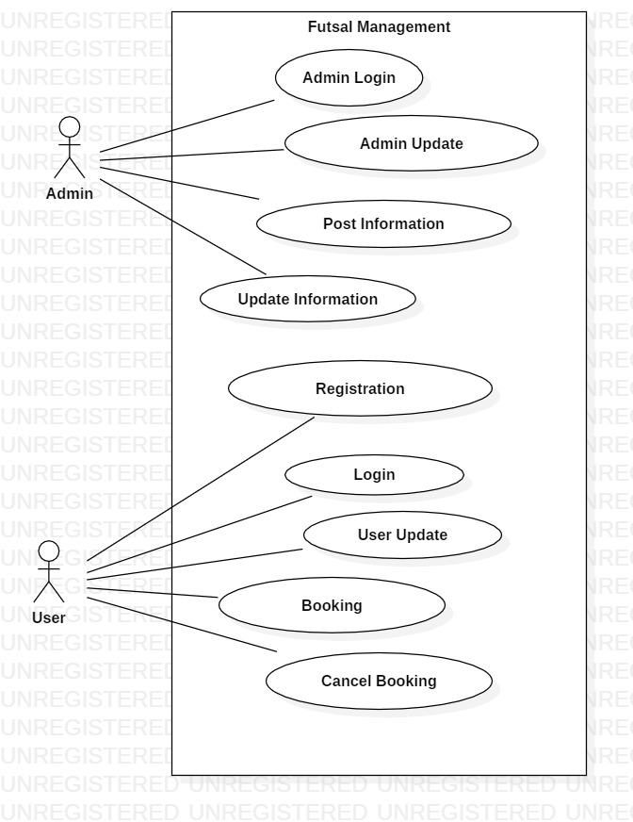

Fig: Use Case Diagram

## 2.4 NLA with Initial Class Diagram

### Introduction

As per the college’s requirement we are required a computer project. For my project I have decided to develop a website. This website will be for the proper management of a futsal system. This futsal management website will include the facilities like booking, registration etc.

By using the website, the users can register their account and log into the website’s account so that they can access the futsal system online. There they can book a particular futsal in which they desire and also set the time for the booking. They can also view various posts posted by the admin (futsal owner), search for available booking. Register for upcoming events, give feedbacks, reviews, cancel booking etc. they can easily update their user profiles. There will also be an admin panel to handle the website, update posts etc.

The candidate class list is:

Nouns:

1. College
2. Futsal
3. Users
4. Comment
5. Register
6. Review
7. Admin
8. Booking

Verbs:

1. Booking futsal
2. Search
3. Create
4. Update
5. Cancel

Final Class I have selected for the initial Class Diagram are:

1. Booking
2. User
3. Review
4. Register
5. Admin

Reason I selected the classes are

|  |  |
| --- | --- |
| Booking | It allows the users t book the futsal for use |
| User | Without use the website is not complete, user play a vital role in completion of the website |
| Review | The users can post regarding the futsal, their matches, tournaments |
| Register | In order to use the website fully we should register our account first |
| Admin | Admin is needed to maintain the futsal, website, update blogs, information etc. |

Table: Classes selected

### Initial Class Diagram

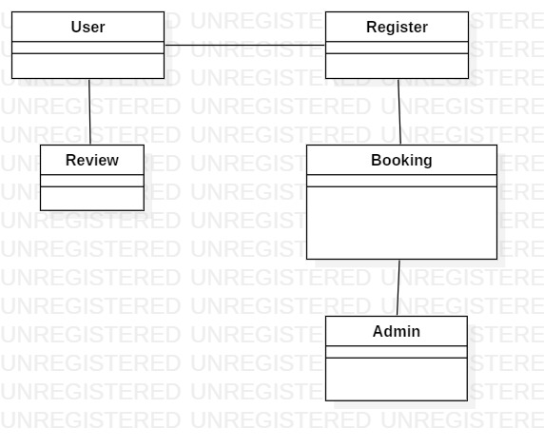

Fig: Initial Class Diagram

# Chapter 3: Design

## 3.1. Introduction

Design refers to creating any image or item on the basis of perspective. Design involves the user perspectives and requirements. while designing a certain object we first find how the object looks and then we do the designing process. Some advantages of designing are:

1. Sets a good impression with customers.
2. Helps to form trust regarding the proposed project.
3. Helps to find what our application or project will look like.

3.2. Structural Design:

The process of investigating the stability, strength and rigidity of a project. It is done for the structural view of a project. Some examples of structural design are: class diagram, flow chart and data flow diagram.

The structural design used for my project are:

### a. Class Diagram

It is a static diagram for the static view of the project. It helps to find what entities are to be included while developing a project.

In my project I have used the class diagram to represent the entities involved while developing the system.

#### Justification:

I my project the class diagram helps to view the static view and the working process of my project. In my project the admin will himself will manipulate the customer account as well as the customer himself. They will also be able to give reviews about the project.

#### Notation used:

Aggregation notation: This notation is used to configure the objects for making the complex type of object.

Composition notation: This notation is used for the composite objects.

Association notation: This type of notation is used to inter-relate the class.

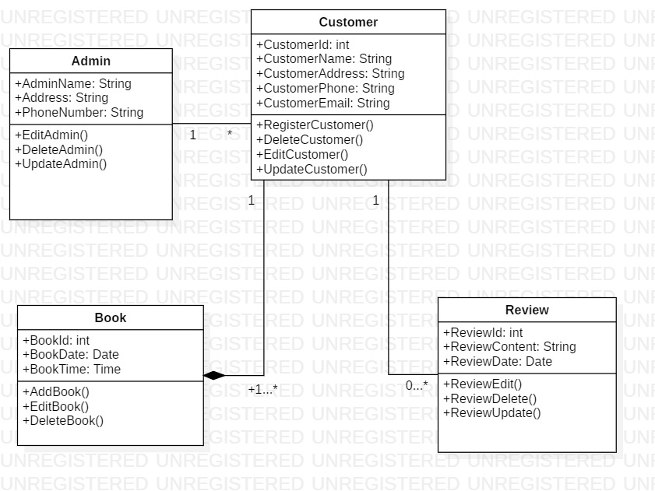

Fig: class diagram

#### Explanation:

My Class diagram consists of 5 classes which are very important for function of my project. There will be a main admin account. The admin can add new customers. After the customer account is created, they can use the website as per their requirement. After they login they can search for the availability of futsal for booking. If available booking can be done if not, they can’t. They can even cancel the booking. They can also post their reviews.

### b. DFD Diagram

DFD is also a type of structural design. The term DFD stands for Data Flow Diagram. This diagram shows the flow of data in our project and how the data are processed. It helps to find the output of our project.

In the image provided below we can easily find out the working mechanism and data flow of my project.

#### Justification:

Data flow diagram are used to graphically represent the flow of data in a information system. It is an essential part of a project because it helps to find the proper flow of data in the system.

#### Notations used:

Process Notation: This notation helps to transfer the incoming data flow into the outgoing data flow.

External entity notations: This notation gives a clue about the objects outside of the system.

Data flow notation: This notation helps to find the flow of data in what direction.

Data stores Notation: This notation shows the database of the system.

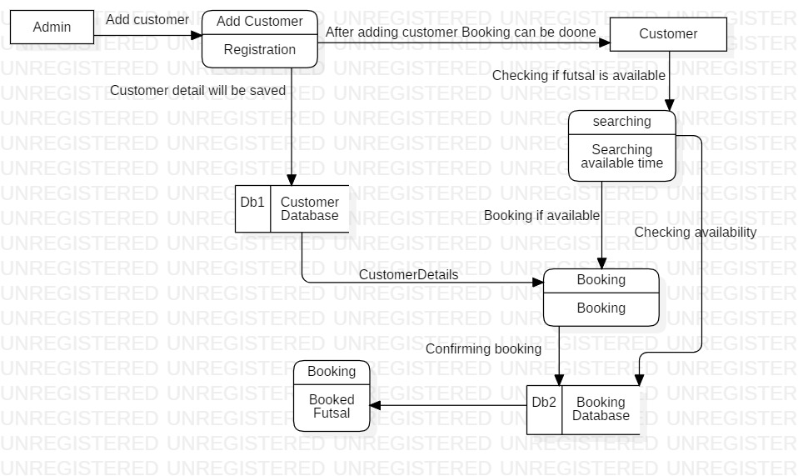

Fig: DFD Diagram

#### Explanation:

The admin is the main entity. First the admin adds the customer. After the customer login they can access the website. They can then book futsal according to their need. The customer data will be stored in the customer database. Booking details will be saved in the booking database.

## 3.3. Behavioral Design:

Behavioral design helps to communicate between two or more objects. It helps to create flexibility among objects.it helps to see how the work is done in the system. The examples of behavioral’ design is: activity and Sequence diagram.

### Activity Diagram:

It Shows the dynamic aspects of a system. It helps to track the activity carried out by the system. It describes the operation of system. Each activity is carried out by using the control flow.

In my project I have also used the activity diagram. It shows the flow of operation and how activities are done in the system.

#### Justification:

Used to see dynamic aspects of the system. It helps to track the systematic flow of process. In my project’s activity diagram, we can easily see what activity is done after what.

#### Notations used:

Start Point: This is the point which represents the initial action state.

Decision branching: This notation helps to decide like if/else condition.

Action flow: This notation helps to flow the object from one action state to another.

Action State: This point represents the non-interruptible actions of the step.

##### Synchronization:

Fork node: This notation helps to split the one action state into two or many.

Join node: This notation helps to combine the two or many action states to one action state.

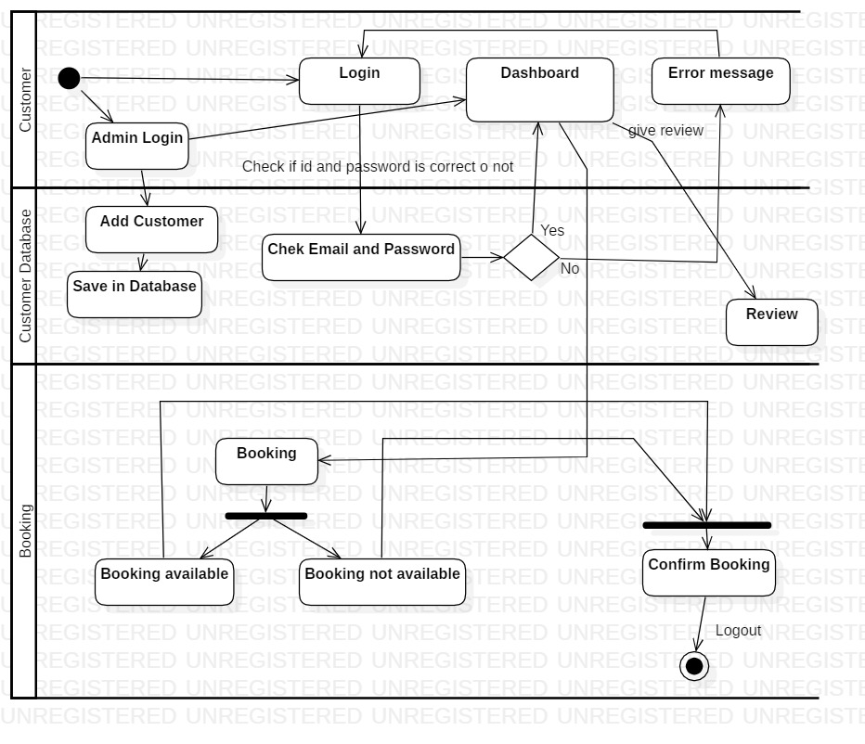

Fig: Activity diagram

#### Explanation:

In the diagram above the admin logs in the system then he can create the customer after the customer account is created, they can access the website. Then if login is successful, they can book futsal.

### Sequence Diagram:

Sequence diagram provide detail about how the system is operated. It helps to find the activities done in the system sequentially. It tracks the data flow and activities carried out between various entities or objects.

I have also used the sequence diagram in my project. The diagram is given below.

#### Justification:

I have created a sequence diagram to know the flow of data and the interactions between the objects.

#### Notations used:

Lifeline: This notation helps to represent the all instance in every interaction.

Message: This notation helps to send the text.

Actor: This notation is for the object which is important for the system to run.

Combine fragment: This type of notation helps to write down the if/else statement.

Message reply: This notation helps to reply the text to the object.

Self-message: This notation helps to write the text to own self object.

Object: This is the class like structure without which system flow isn't possible.

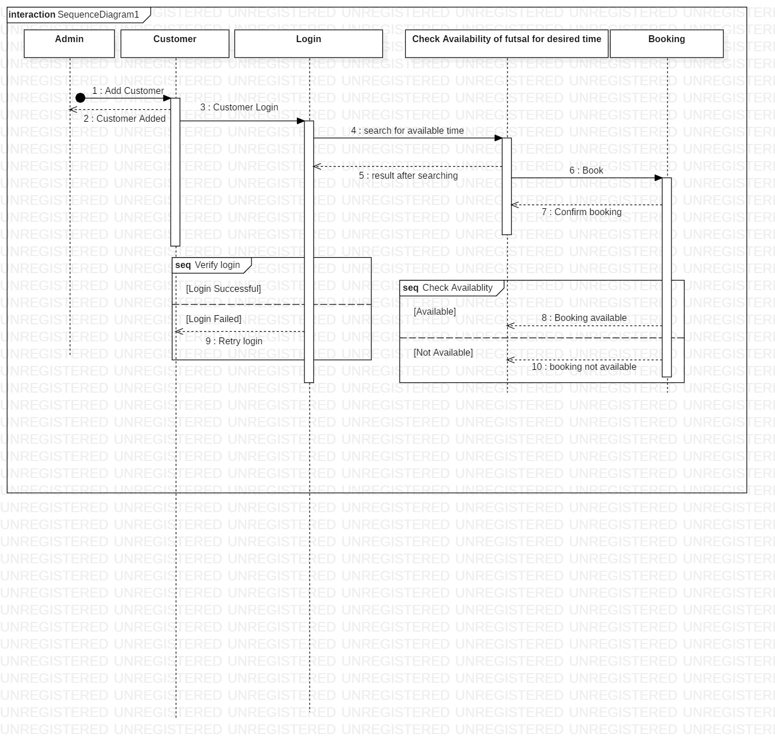

Fig: Sequence diagram

#### Explanation:

In the diagram above the flow of data is shown. We can clearly see how the data flows inn the system, we can also see the processes that are done after completion of certain task.

## 3.4. Database Management System

It is the management of the database using various processes. We create various databases according to the requirement and we can also carry out various activities like add, delete update etc.

Some advantages of using the DBMS are:

* Data Abstraction
* Data security
* Data independence
* Robust data integrity
* Simple access using API

### Data Dictionary

It is also called a metadata. It contains various files and sets of data. Data dictionary contains the databases the tables etc. it is an important component of the relational database. It contains various elements of a database.

#### Justification:

In my data dictionary I have altogether 5 entities in the metadata. List pf those entities are:

Data Dictionary of Admin

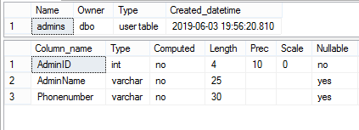

Data Dictionary of Customer

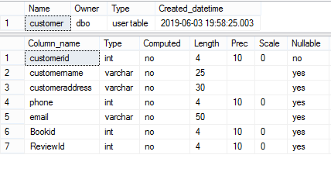

Data Dictionary of Booking

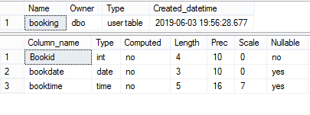

Data Dictionary of Review

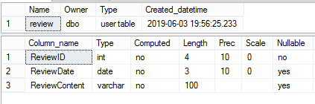

#### Explanation:

The above pictures include the entities used in the system. It shows the datatype, length, null or not-null value etc.

### ER Diagram:

It is also known as Entity Relationship Diagram. Ir provides the relation between the entities.it helps to develop complex database.

#### Justification;

For my project I have altogether 5 entities. The entities with proper column name are:

* Admin
* Customer
* Booking
* Review

#### Notations Used:

Fields: This notation is used to classify the entity and their columns.

Keys:

Primary key: This key uniquely identifies the column.

Foreign key: This key is created any time an attribute relates to another entity.

##### Cardinality and Ordinality

Cardinality and Ordinality are the notations that are used to relate the one instance of one entity to another instance of another entity.:

One to many: This notation helps to relate the one instance of one entity with the many instance of another entity.

Many to many: This notation helps to relate the maximum number of times an instance in one entity with other many instance of another entity.

There is also another notation i.e. (One to one)

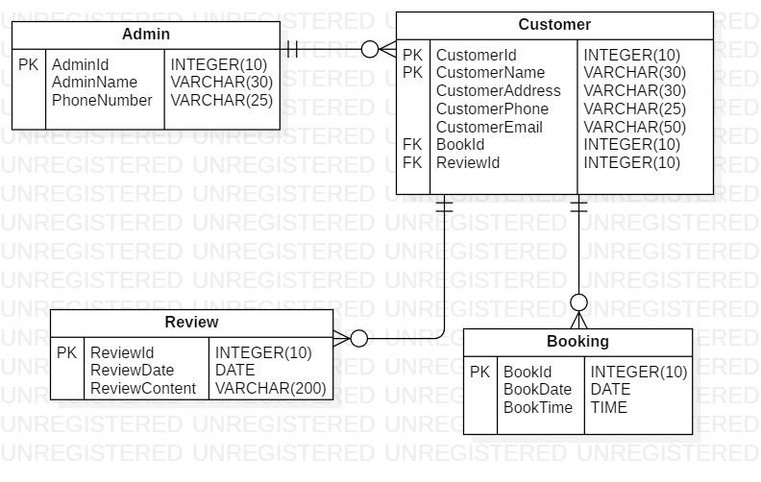

Fig: ER diagram

#### Explanation

In the diagram above the relation between various entities are shown as well as the various entity types. It shows the dependency of each entity with another entity.

## 3.5. Architecture

It is an important fundamental structure to give shape tour system. It is also regarded as the blue print of the system. It helps in the designing, development of the system and its maintainability.

I used the 3-tier architecture for my project. As it is the most commonly used architecture in the DBMS.

A 3-tier architecture separates its tiers from each other based on the complexity of the users and how they use the data present in the database. (dbms_architecture,2.19)

The 3-tier architecture works with the help of the Presentation, Application and Database tier.

1. Presentation tier

In the presentation tier the operations of users will be done. They can only see the objects available to them. They have no access to the database. More like they can only see the frontend of the system.

1. Application tier

In this tier the connection between the application server and the database is shown. The users can only see the virtual database. It can also be called the abstract database.

1. Database tier

In the database tier all the data’s regarding the system will be stored. The query and its processing will also be shown.

#### Justifications:

For the final completion of the project the prototype of the system is listed below. The prototype will more or less be similar to the actual website(webpage).

## Prototype Of the project (Paper Prototype)

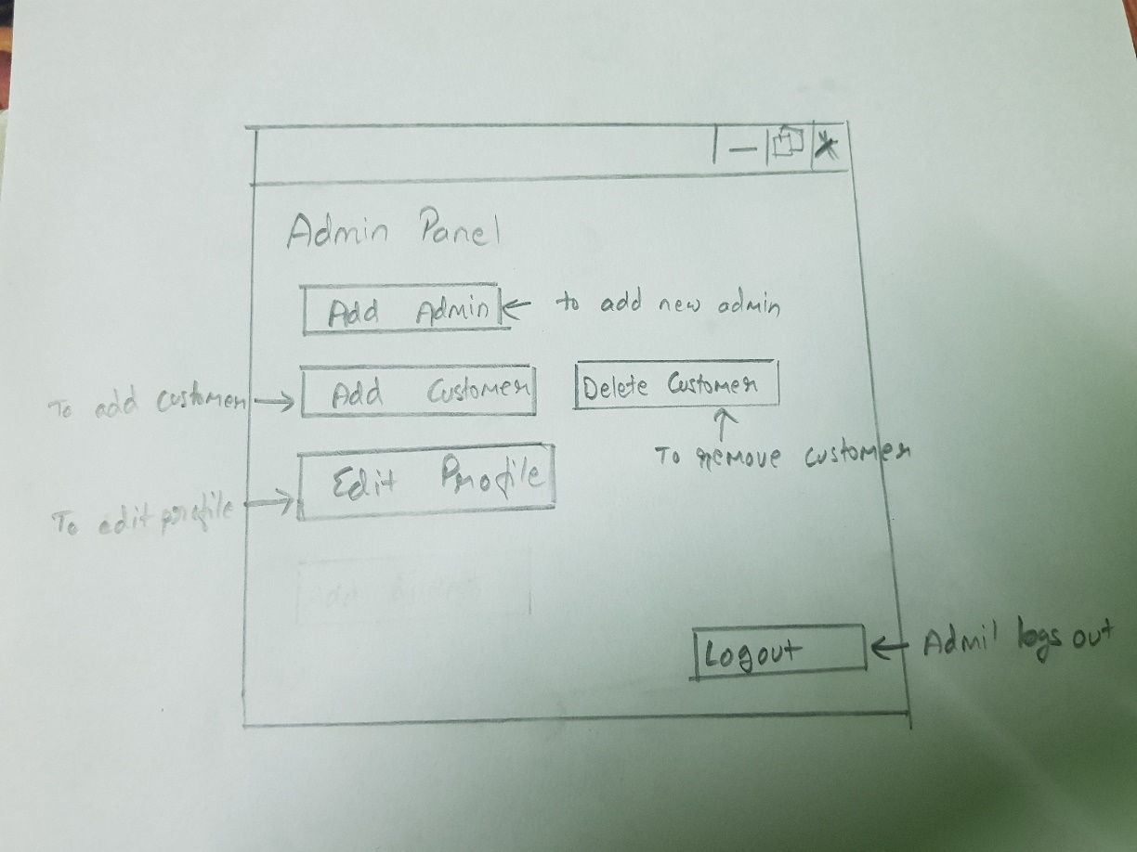

Pic: Admin Panel

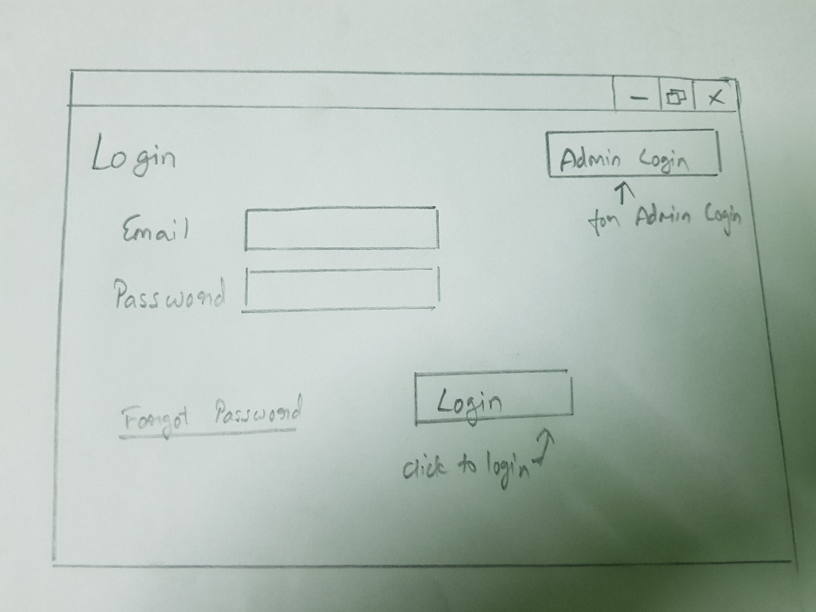

Pic: Login Page

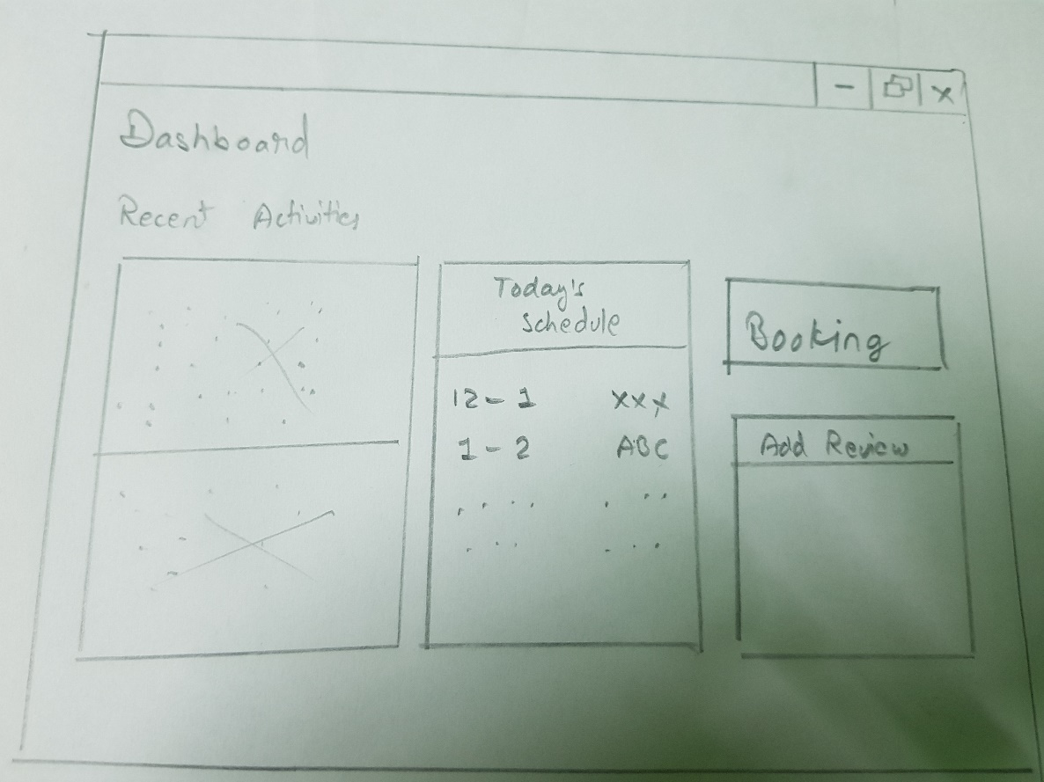

Pic: Dashboard

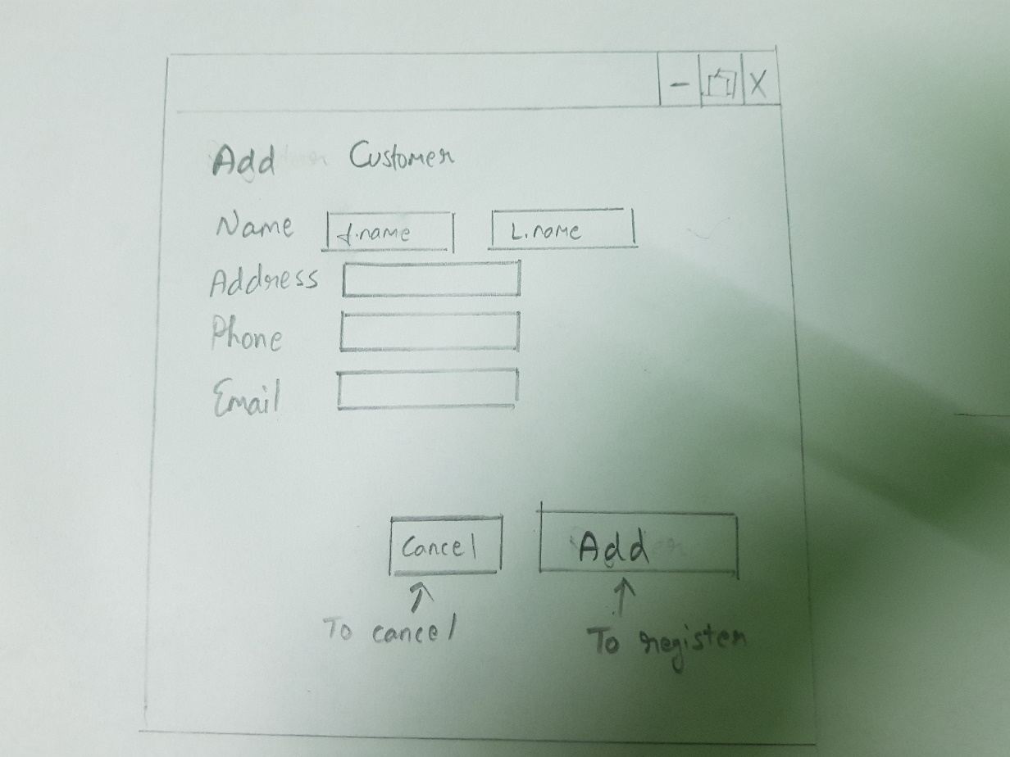

Pic: Customer Registration

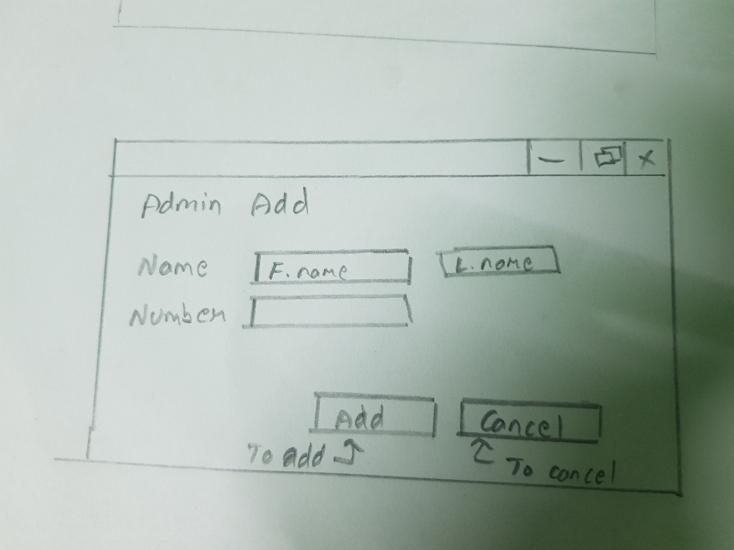

Pic: Add admin page

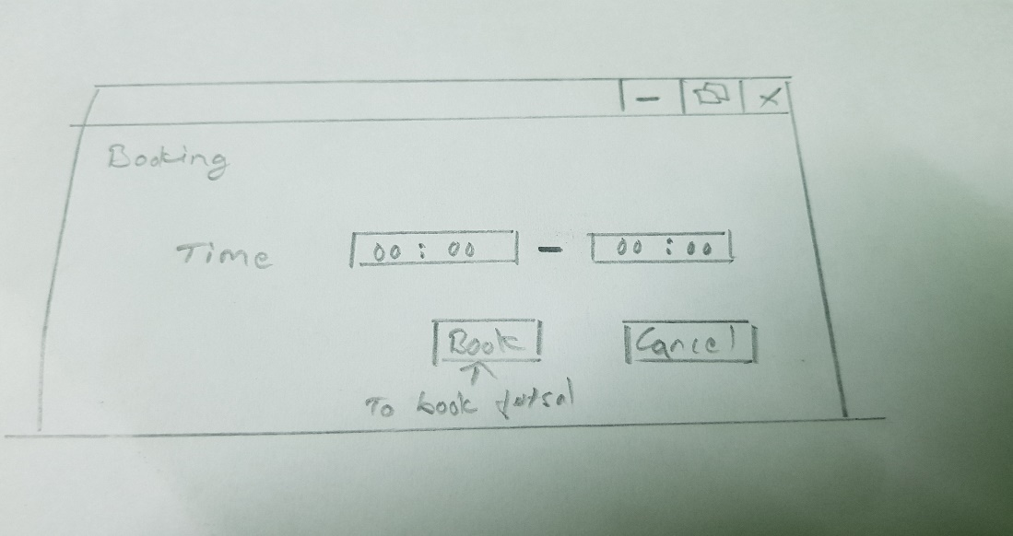

Pic: Booking Page

Explanation

The above images are the images of the paper prototyping. The prototyping is a basis for the actual design of the system they may also vary according to the situation and desire. Prototype helps to develop the website easily and gives information about how system will look after completion.

# Chapter 4: Implementation

In this step the project is developed. To develop my project, I have used the PHP, JavaScript to develop the website. The project is built using PHP, JavaScript etc. and other required tools to maintain the standard of the website.

The project code and the UI design is attached in the appendix

# Chapter 5: Testing

1.Unit Testing:

UNIT TESTING is a level of software **testing** where individual units/ components of a software are tested. The purpose is to validate that each **unit** of the software performs as designed. A **unit** is the smallest testable part of any software. It usually has one or a few inputs and usually a single output.

# 2. Black Box Testing:

Black Box Testing, also known as Behavioral Testing, is a software testing method in which the internal structure/design/implementation of the item being tested is not known to the tester. These tests can be functional or non-functional, though usually functional.

Advantages of using black box testing are:

* Efficient when used on large systems.
* Testing helps to identify contradictions in functional specifications.
* No need for the tester to have detailed functional knowledge of system.
* Tests will be done from an end user's point of view, because the end user should accept the system. (This testing technique is sometimes also called Acceptance testing.)
* Test cases can be done as soon as the functional specifications are complete.
* Since the tester and developer are independent of each other, testing is balanced and unprejudiced.
* Tester may be non-technical.

List of Black Box Testing ae:

## Test Name: Login Test

## **Pre-condition**: User must get log into the system

|  |  |  |  |  |  |
| --- | --- | --- | --- | --- | --- |
| **Test no** | **Test**  **Scenario** | **Test Input Data** | **Expected result** | **Actual result** | **Result**  **(Pass/Fail)** |
| 1 | To check if the user logs in or not | Email:  aa@gmail.com Password:123 | User should log in | User logs in | pass |

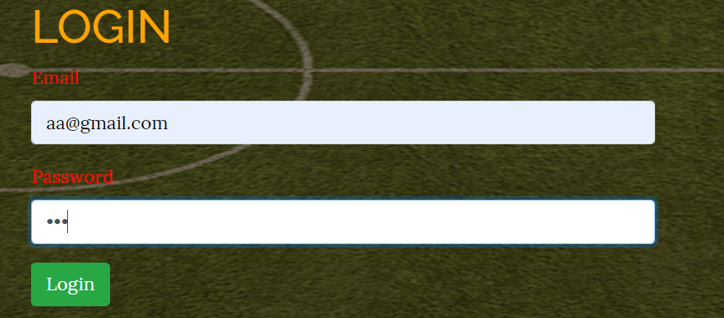

## Test Name: creating account Test

## **Pre-condition**: account must get create

|  |  |  |  |  |  |
| --- | --- | --- | --- | --- | --- |
| **Test no** | **Test**  **Scenario** | **Test Input Data** | **Expected result** | **Actual result** | **Result**  **(Pass/Fail)** |
| 2 | To check if the account is created | Name: Zen  Address: Ktm  Email:  zen@gmail.com Password:111 | Account should be created | Account created | pass |

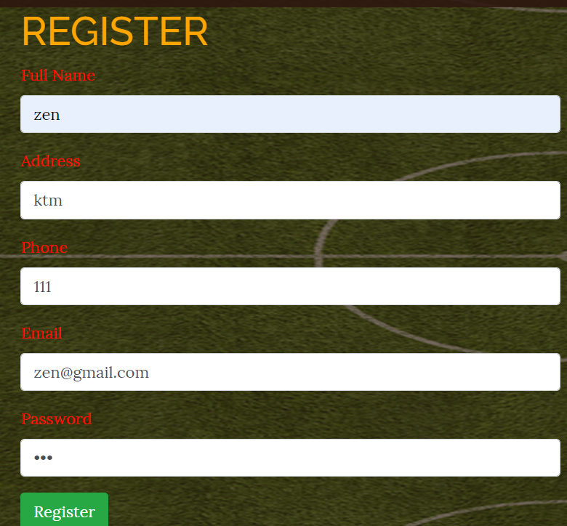





## Test Name: booking Test

## **Pre-condition**: booking must be done

|  |  |  |  |  |  |
| --- | --- | --- | --- | --- | --- |
| **Test no** | **Test**  **Scenario** | **Test Input Data** | **Expected result** | **Actual result** | **Result**  **(Pass/Fail)** |
| 3 | To check if booking is done | Name: Zen  Address: Ktm Phone: 111  Date: 2019-07-05  Time: 10:00 | Booking should be done | Booking done | pass |

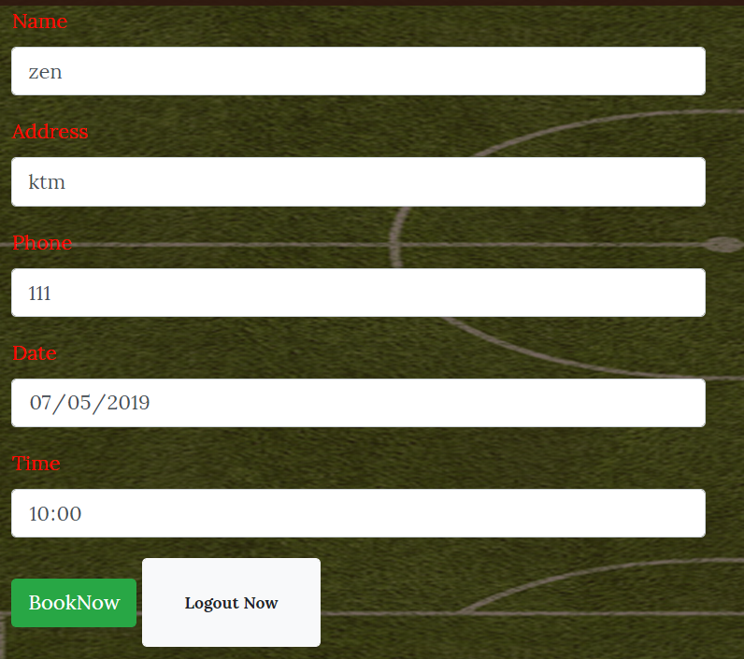





## Test Name: booking Test for same time

## **Pre-condition**: booking must not be done because of the same time

|  |  |  |  |  |  |
| --- | --- | --- | --- | --- | --- |
| **Test no** | **Test**  **Scenario** | **Test Input Data** | **Expected result** | **Actual result** | **Result**  **(Pass/Fail)** |
| 4 | To check if booking is done | Name: Zen  Address: Ktm Phone: 111  Date: 2019-07-05  Time: 10:00 | Booking should not be done | Booking not done | pass |



## Test Name: creating account Test

## **Pre-condition**: account must not be created because account already exists

|  |  |  |  |  |  |
| --- | --- | --- | --- | --- | --- |
| **Test no** | **Test**  **Scenario** | **Test Input Data** | **Expected result** | **Actual result** | **Result**  **(Pass/Fail)** |
| 5 | To check if the account is created | Name: Zen  Address: Ktm  Email:  zen@gmail.com Password:123  Phone:111 | Account should not be created | Account not created | pass |





## Test Name: password availability Test

## **Pre-condition**: account must not be created because password is not set

|  |  |  |  |  |  |
| --- | --- | --- | --- | --- | --- |
| **Test no** | **Test**  **Scenario** | **Test Input Data** | **Expected result** | **Actual result** | **Result**  **(Pass/Fail)** |
| 7 | To check if the account is created | Name: Zeni  Address: Ktm  Email:  zem@gmail.com Password:  Phone:111 | Account should not be created | Account not created | pass |

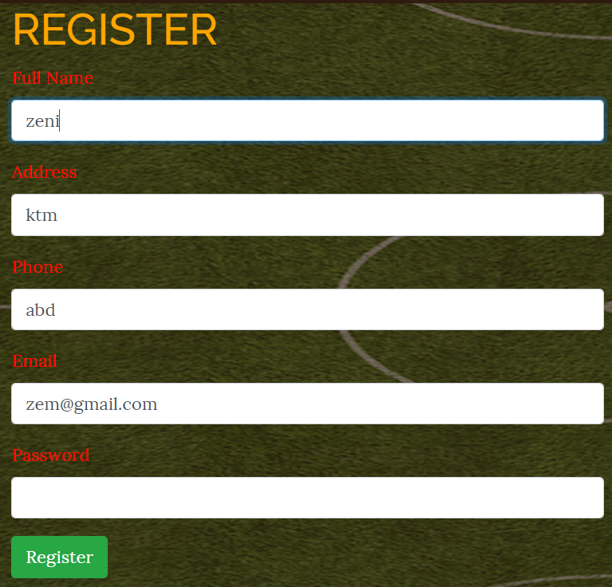

## Test Name: email availability Test

## **Pre-condition**: account must not be created because email is not set

|  |  |  |  |  |  |
| --- | --- | --- | --- | --- | --- |
| **Test no** | **Test**  **Scenario** | **Test Input Data** | **Expected result** | **Actual result** | **Result**  **(Pass/Fail)** |
| 8 | To check if the account is created | Name: Zeni  Address: Ktm  Email:  Password: 123  Phone:123 | Account should not be created | Account not created | pass |

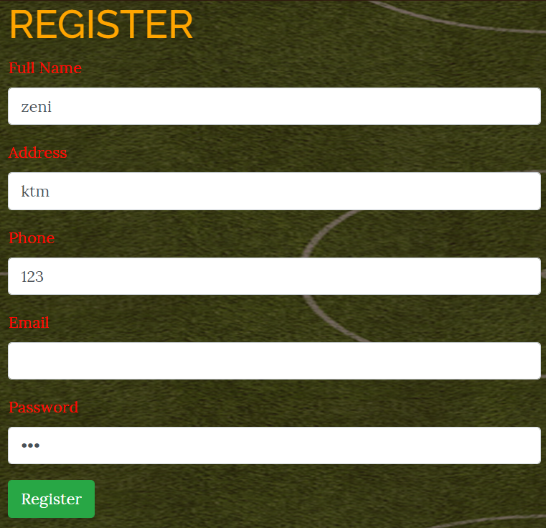

## Test Name: password Test

## **Pre-condition**: login is not done because wrong password

|  |  |  |  |  |  |
| --- | --- | --- | --- | --- | --- |
| **Test no** | **Test**  **Scenario** | **Test Input Data** | **Expected result** | **Actual result** | **Result**  **(Pass/Fail)** |
| 9 | To check if the account logs in | Email: zen@gmail.com  Password: 135 | Login is not done | Not logged in | pass |

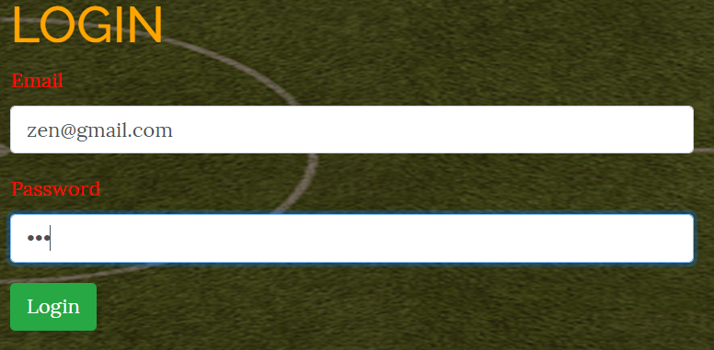

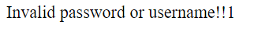

## Test Name: login email Test

## **Pre-condition**: login is not done because wrong email

|  |  |  |  |  |  |
| --- | --- | --- | --- | --- | --- |
| **Test no** | **Test**  **Scenario** | **Test Input Data** | **Expected result** | **Actual result** | **Result**  **(Pass/Fail)** |
| 10 | To check if the account logs in | Email: ze@gmail.com  Password: 123 | Login is not done | Not logged in | pass |

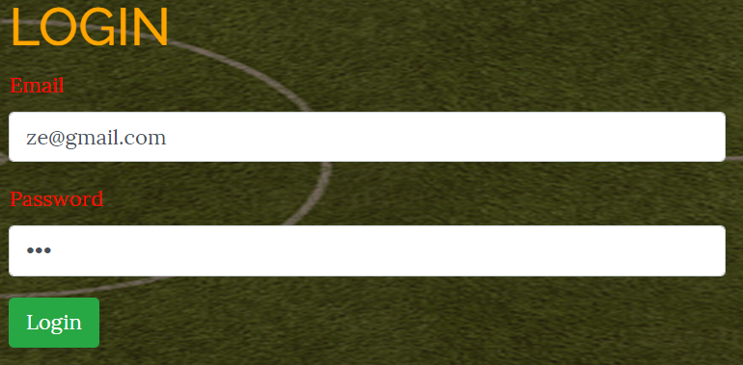

# Chapter 6: Other Project Issues

## Risk management

While developing a project there may arise various risks. So, we should define the risk before the project is started. These risks can have significant effects on the project development. So, we should define such risk and then identify its solution beforehand to reduce the impact upon the project.

Below is some probable risk that may occur while developing the project. Also, their likelihood, impact etc. are shown.

Risks that may occur are:

* Hard disk crash
* Sickness
* Data theft
* Damage of devices
* Natural disasters
* Software crash
* Change of requirement

|  |  |  |  |  |
| --- | --- | --- | --- | --- |
| Risk | Likelihood | Consequence | Impact | Action |
| Hard disk crash | 2 | 5 | 10 | Back up |
| Sickness | 3 | 4 | 12 | Taking proper care |
| Data theft | 1 | 3 | 3 | Keeping property securely |
| Damage of devices | 2 | 5 | 10 | Backup |
| Natural disasters | 1 | 5 | 5 | Backup of data |
| Software crash | 2 | 3 | 6 | Backup of data |
| Change of requirements | 3 | 4 | 12 | Using proper development policy |

## Configuration management

Configuration management refers to the storage od project files on the system using the subfolders and folder wise storage. Sub steps should also have their own sub folders. For back up I have created separate folder to store the data of each development progress.

## Future work

Main objective of developing this system is to provide service for the user to book a spot for futsal activity. They also can get the posts of the futsal organization. The system can further be developed by adding various features. Some of the features that can be added in the system are:

* Users will be able to register themselves.
* To view the number of times they have booked the futsal
* To view another users’ information
* Payment through online system

## Limitation

Limitation refers to the limit of a task a project can handle. The project I have developed have very limited features. Currently there are only about 5 actions that can be done on the website. The task that can be done currently on the website are:

* Create account
* Book futsal
* View futsal opening schedule
* Remove account

# Chapter 9: Appendix

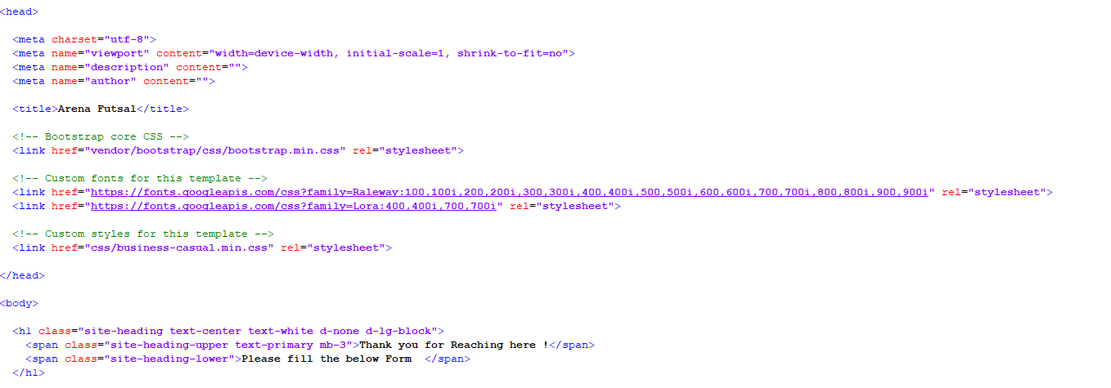

Pic 1: Bootstrap



Pic 2: Navigation Bar UI

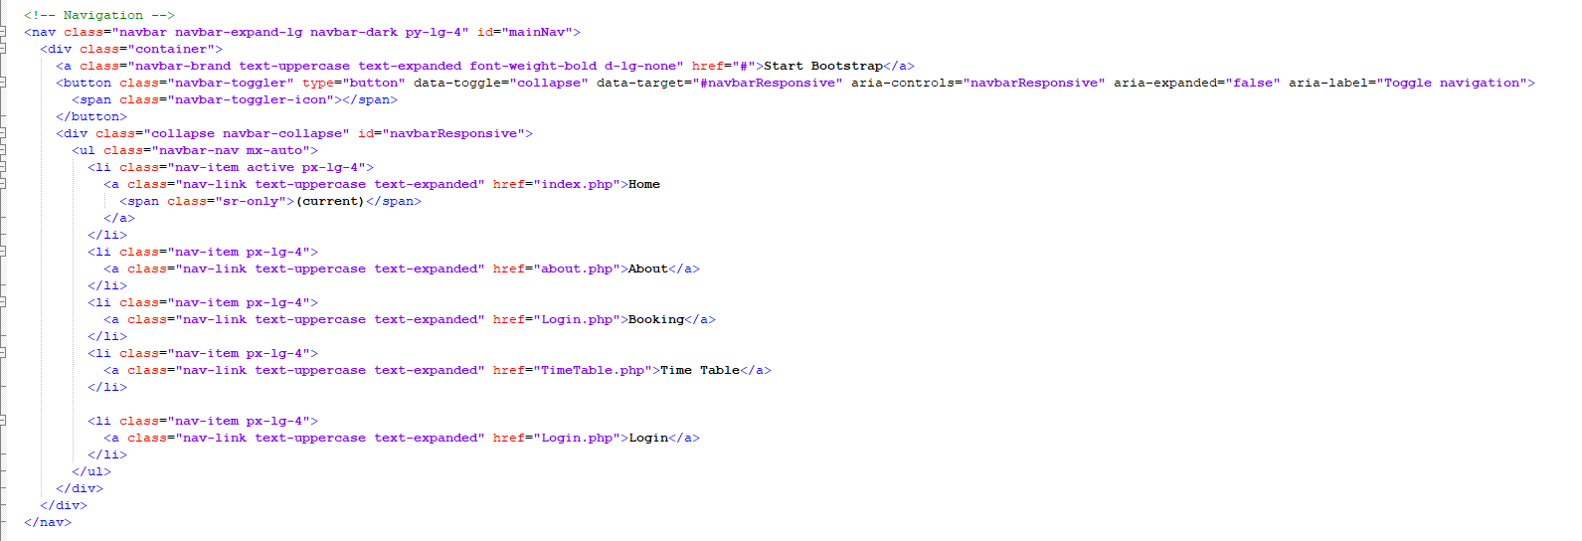

Pic 3: Navigation Bar Code



Pic 4: Footer UI

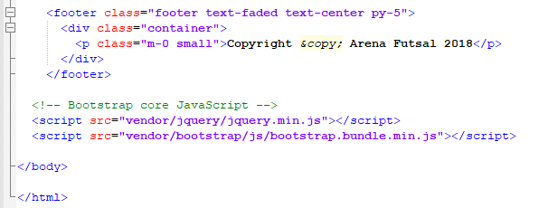

Pic 5: Footer Code and Bootstrap Remaining codes

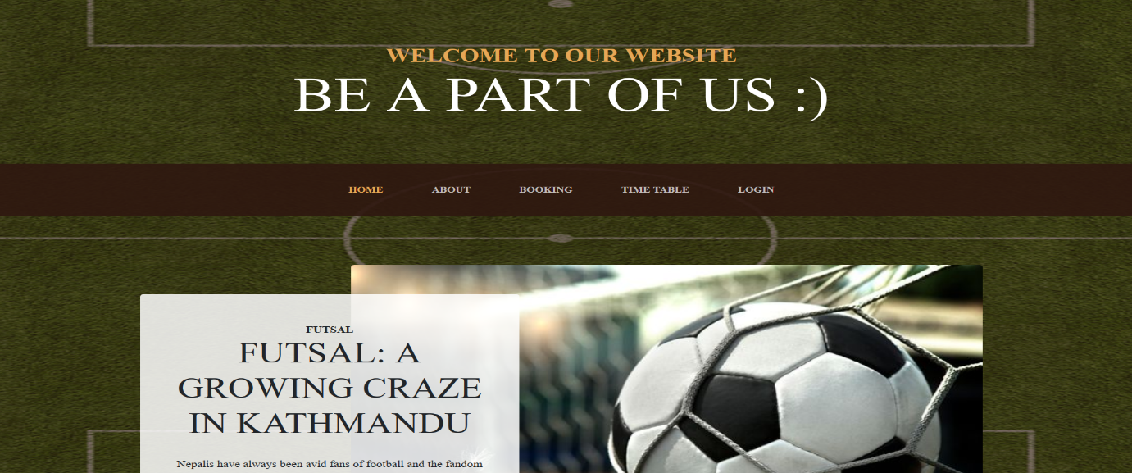

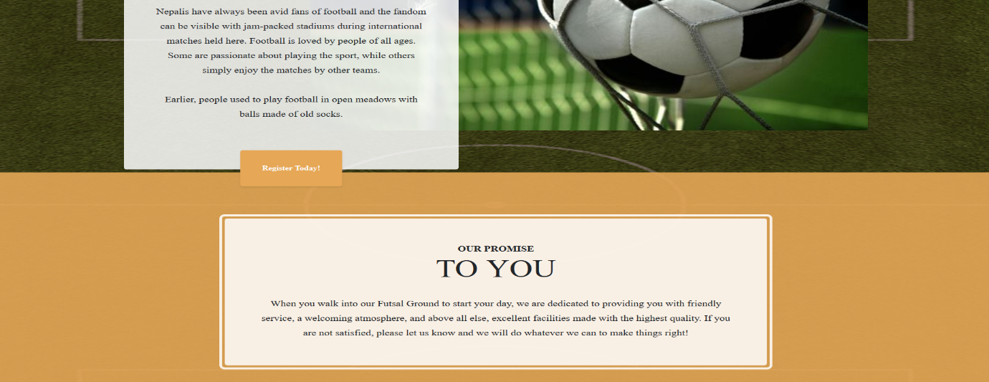

Pic 6-7: Index UI

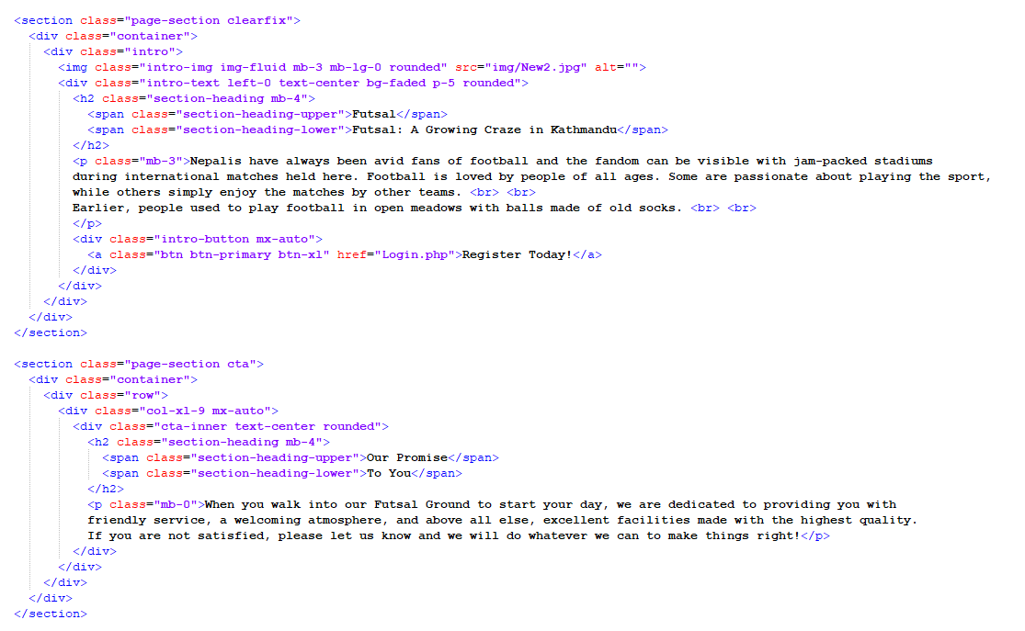

Pic 8: Index Code

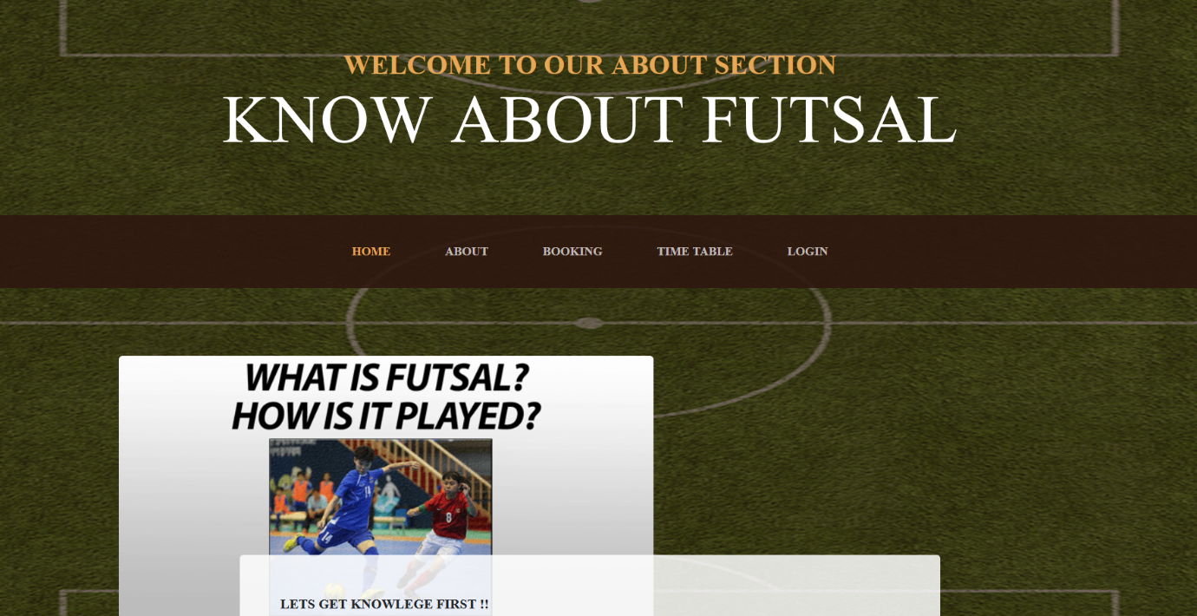

Pic 9: About UI

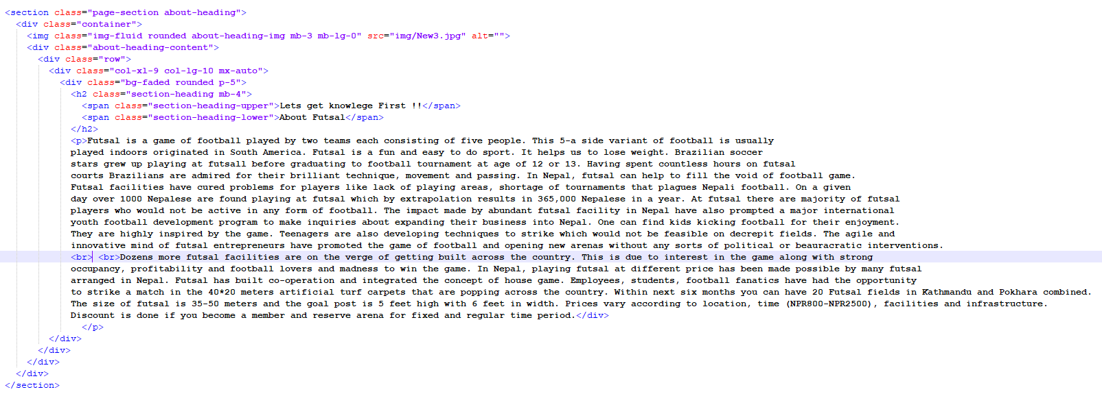

Pic 10: About Code

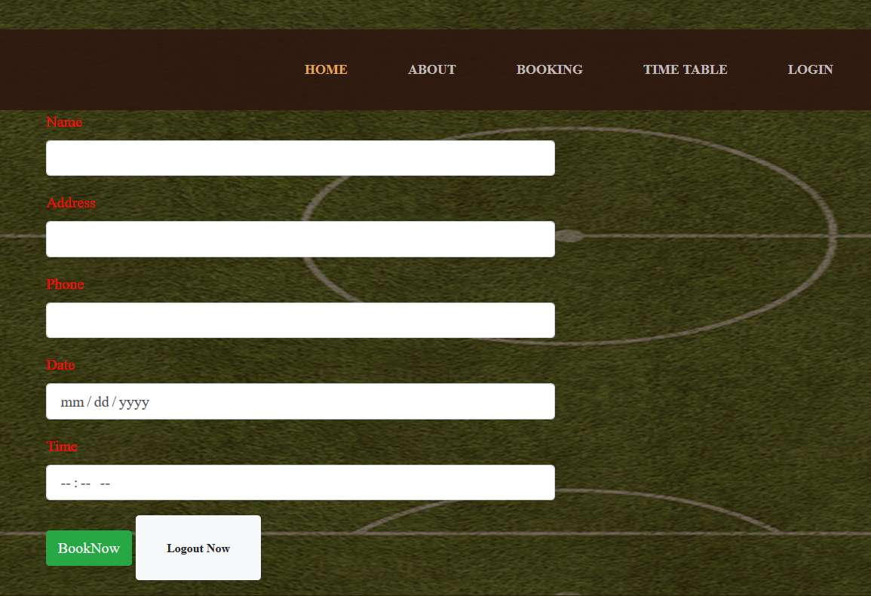

Pic 11: Booking UI

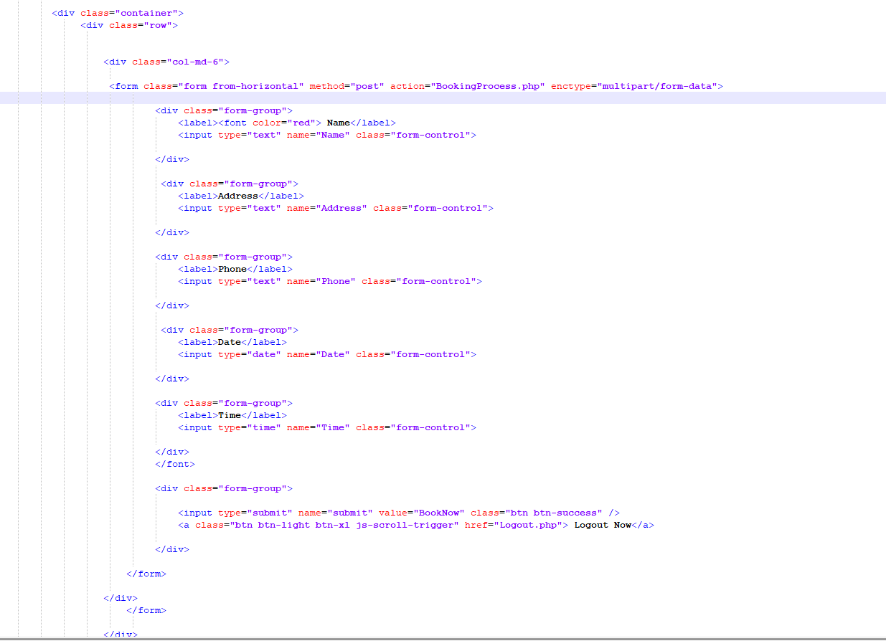

Pic 12: Booking Code

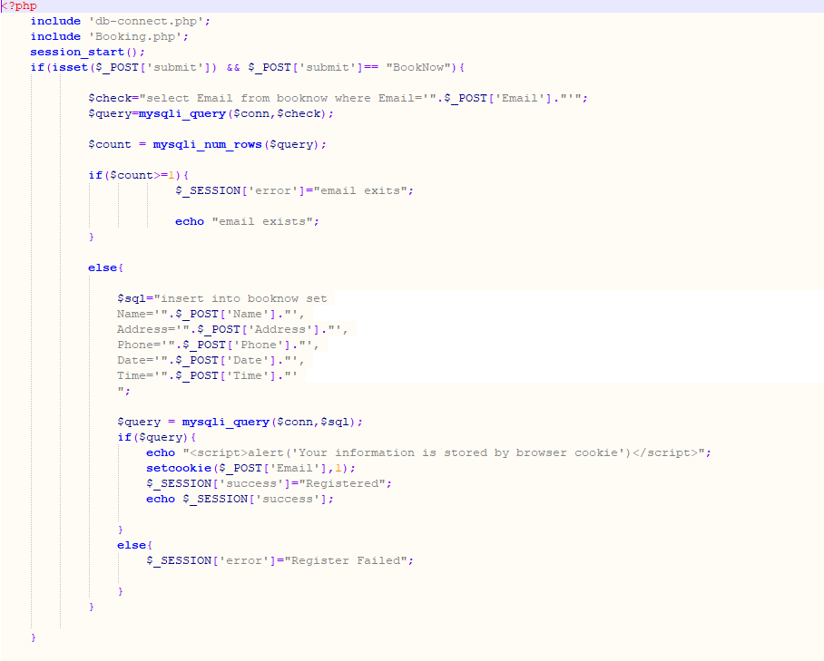

Pic 13: Booking Process 1

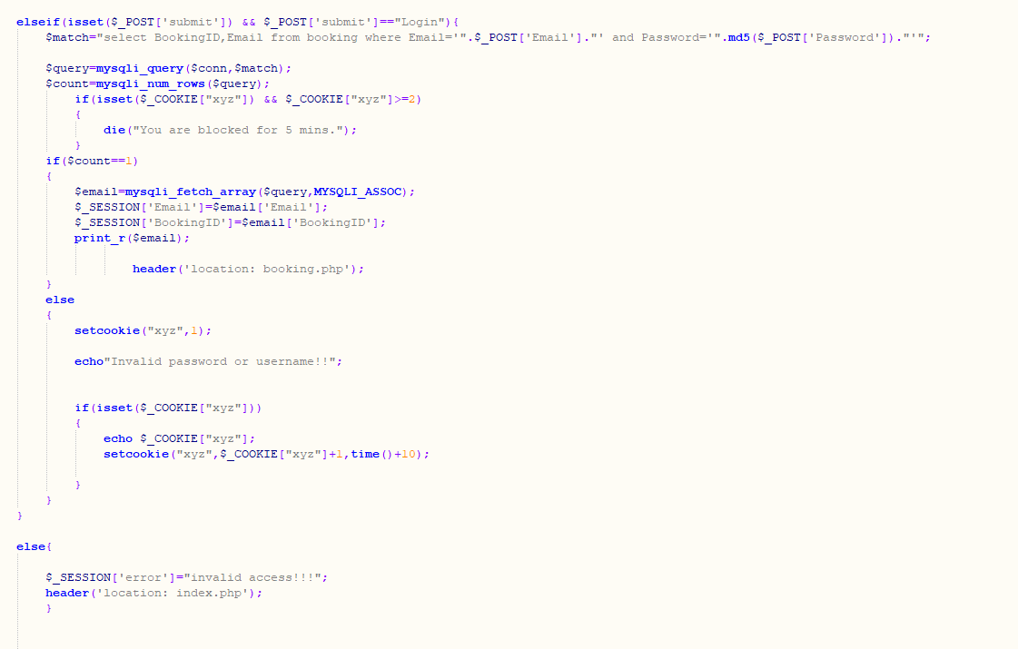

Pic 14: Booking Process 2

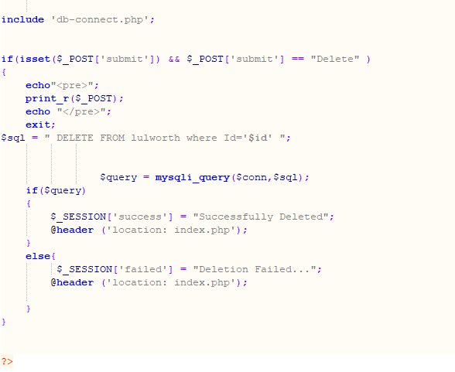

Pic 15: Booking Process 3

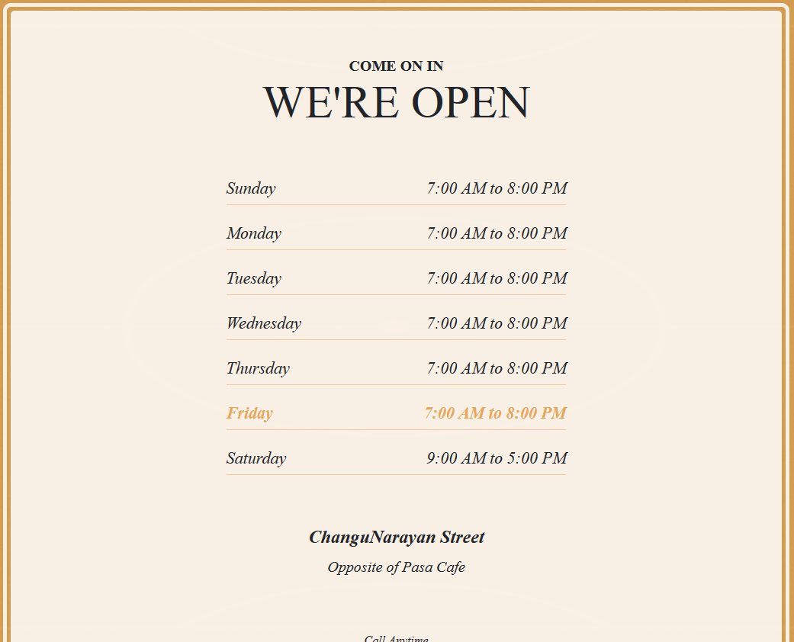

Pic 16: Timetable UI

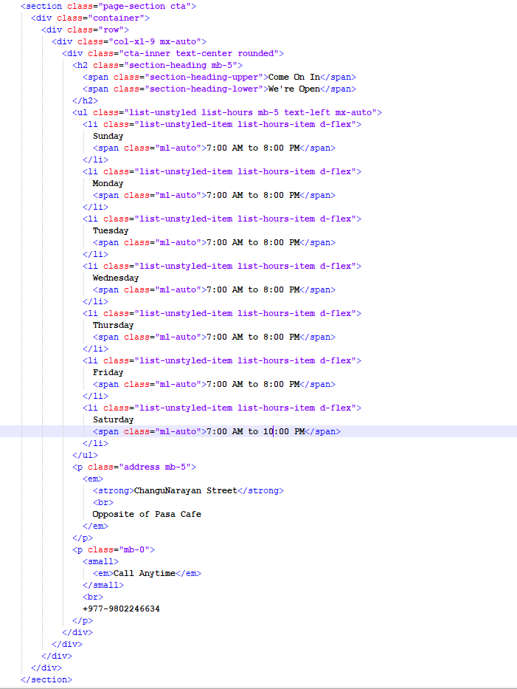

Pic 17: Timetable code

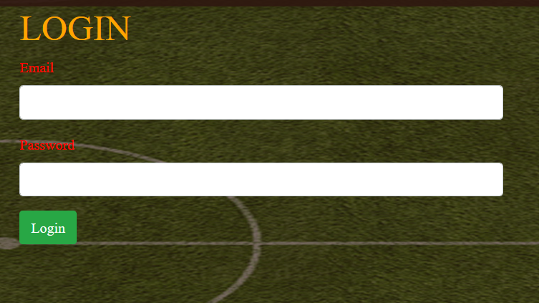

Pic 18: Login UI

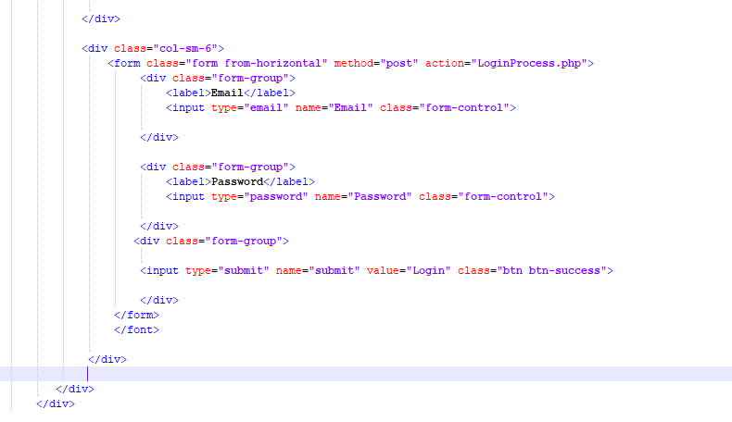

Pic 19: Login Code

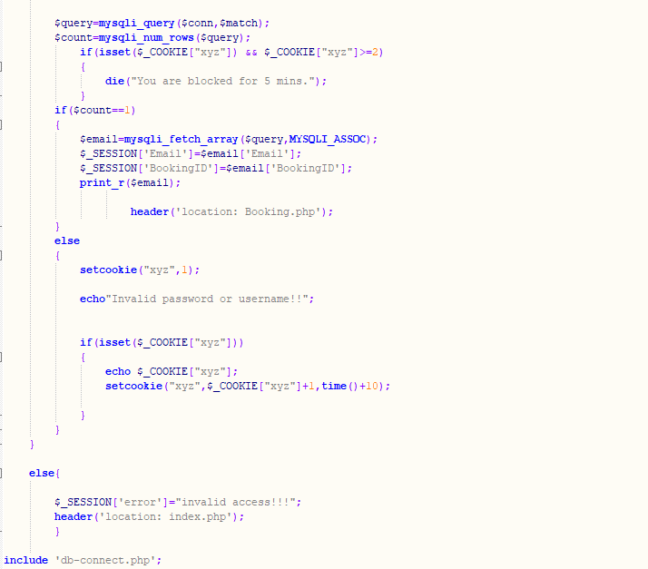

Pic 20: Login Process Code 1

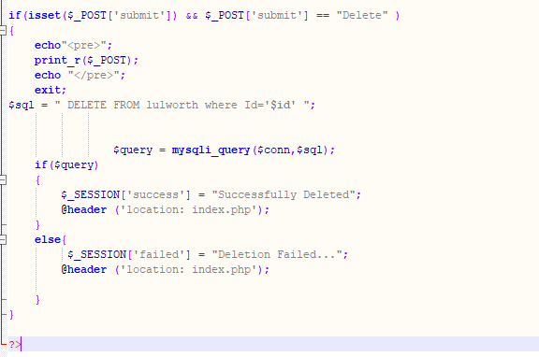

Pic 21: Login Process Code 2

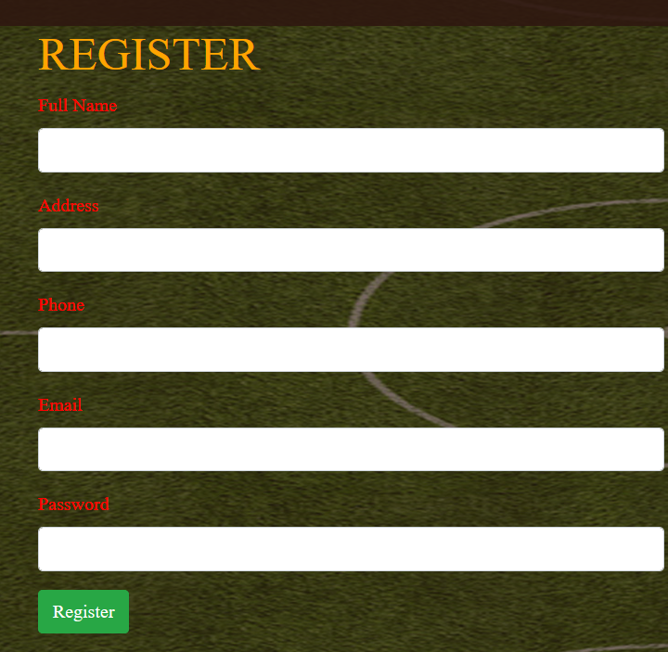

Pic 22: Registration UI

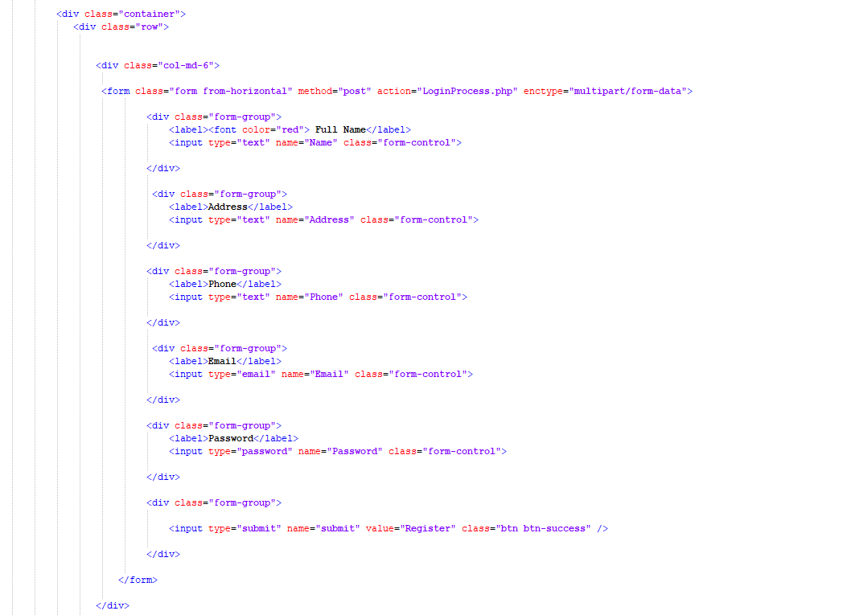

Pic 23: Registration Code

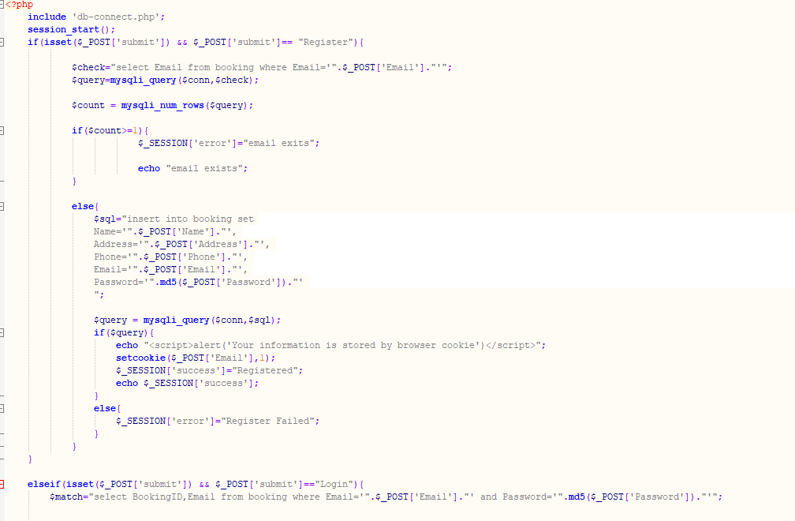

Pic 24: Registration Process Code